Application for KMI-PEMSEA Training Program
on Marine Ecosystem Services and Spatial Management Tools

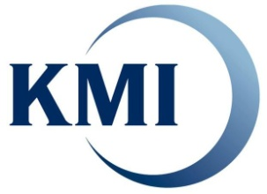
Korea Maritime Institute
26, Haeyang-ro 301beon-gil, Yeongdo-gu, Busan, 49111, Korea
Please send this application form to Miju KIM, mijukim.ocean@gmail.com

I. Personal Data

- Full Name:
First Middle Last (Surname)
- Date of Birth : / / (mm/dd/year) ♦ Gender : □ male □ female
- E-mail : /(alternative)
II. Education and Skills

- Education : □ Ph.D □ Ph.D candidate □ Master □ Undergraduate
- Academic Background :
- English : □ Excellent □ High □ Medium □ Beginning
- GIS Skills : □ Excellent □ Medium □ Beginning □ Not yet exp
II. Affiliation & Position
- Present position/title :
- Name of Organization :
- Type of Organization: □ Government/public □ Academic □ Beginning □ Not yet exp
- Address :
- Term of Employment: yrs - from to present
III. Description of your works/studies and Future Plan
(please describe your works/studies, and future plan to use experiences from the training program)

* KMI will cover all costs for air-fares (for international applicants), accommodation, meals and local transportation for a field trip.
** Submission of the application form does not imply admission to the training program. Seats for the training program are limited.
*** Admitted trainees have to bring their own lap-top computers and local data/information for exercise at the training program

