First Circular

Join us everyone, in inspiring all generations and inspiring new geography!
This Asia-based conference has provided academic exchanges and discussion by dedicated researchers, mainly young geographers from Japan, Korea and China, since 2006. The 11th conference will be held in Sapporo, Hokkaido, Japan in 2016. Join us, enjoy academic exchange and deepen your friendship!

- SCHEDULE
September 11-14, 2016

- VENUE
Sapporo, Hokkaido, JAPAN
New Otani Inn Sapporo (http://newotanisapporo.com/lang/)

- THEME
Frontiers of Asian Geography: talking about the decade, creating our future with young spirits
The topic of this conference, “ Frontiers of Asian Geography: talking about the decade, creating our future with young spirits”, implies the economical and social development of diverse regions, and the occurrence of various sorts of problems in Asia. We hope to enhance the partnership between all Asian countries, and to create a place that brings up new issues and puts forward policy recommendation from a geographical approach. This conference also intends to contribute to building future generations with global perspective. In addition, this conference has provided opportunities for international researchers from Asia to present and discuss their latest research. We hope that all generations can join us, exchange ideas and create friendships with geographers.

- PROGRAM PLAN
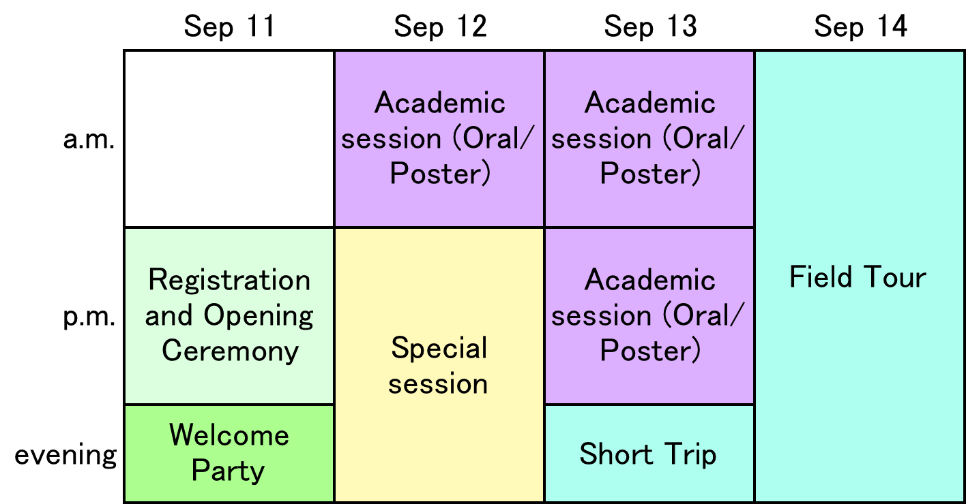

- OFFICIAL LANGUAGE: English

- REGISTRATION
Register via online: http://11thcon.geographers.asia/registration/sign-up/
If you need to make any change after registration, you can provide update on the revise form.
We will send more detailed information for abstracts and proceedings papers to your e-mail address after we confirm your registration. We will require an abstract of 400-600 words for each presentation. If you submit an entry for the prize, you must also submit a proceedings paper of fewer than 2,000 words. Figures and tables can NOT be included in both abstracts and proceedings paper.

- TOPICS: Human/Physical Geography, Geomorphology, Climatology, Interdisciplinary Research
We welcome various theme and target from a Geographical perspective：
- urban/rural transformation, aging society, population explosion, globalization, neoliberalization,
- global/local climate change, heat island, paleoclimatology,
- culture and community, global/local environment and governance in East Asia,
- landscape response to tectonic and climatic forcing, structural and chronological evolution of active fold and thrust belts, risk management in East Asia,
- GIS/RS based analysis, geographical research on new theories and new methods and so on

- DEADLINE
*Registration will start from April 1, 2016.
Registration: June 30, 2016
Abstract/proceedings paper submission: June 30, 2016

- FEES & HOTEL
- Overseas participant: 60,000JPY
covers hotels (4 night, September 11-14), admission to the conference (including the conference packages), 4 breakfasts, 3 lunches & coffee breaks, the welcome party, the farewell party and the field tour. The organizing committee will reserve your hotels for participants.

- Domestic participant: 30,000JPY
covers admission to the conference (including the conference packages), 3 lunches & coffee breaks, the welcome party, the farewell party and the field tour. This fee does NOT cover any accommodation. Please reserve your own hotel room. If you would like to be reserved the hotel room by the organizing committee, your fee will be the same as overseas participants (60,000JPY), too.
- ORGANIZATION
Organizer: The Organizing Committee of the 11th Japan-Korea-China Joint Conference on Geography
Supporters: The Association of Japanese Geographers (AJG)
The Korean Geographical Society (KGS)
The Geographical Society of China (GSC)

- ORGANIZING COMMITTEE
Chairperson:
YAMADA Harumichi (Tokyo Keizai University)
Secretary-General:
SASAKI Toru (Sapporo Gakuin University)
Members of Committee:

ARAKI Hitoshi (Yamaguchi University; Commission of Exchange, AJG)
CHAI Yanwei (Peking University)
ENDO Nao (Kochi University)
JEONG Hwan-Yeong (Kongju National University)
KOIZUMI Ryo (Kanagawa University)
KOMAKI Nobuhiko (Aichi University)
KONNO Ena (Japan Livestock Industry Association/Hosei University)
MOTOKI Masatoshi (Tokiwa University)
NIWA Takahito (Teikyo University)
ODA Takashi (Miyagi University of Education)
SEKINE Ryohei (Tohoku University)
SHOJI Gen (Miyagi University of Education)
TADA Tadayoshi (Norinchukin Researchi Institute Co., Ltd/Meiji University)
YAMAMOTO Kenta (Kokugakuin University)
YOSHIDA Kunimitsu (Kanazawa University)

- ADVISORY COMMITTEE
ARAI Yoshio, President of AJG, Japan
YANG Bokyung, President of the KGS, Korea
FU Bojie, President of GSC, China

We will release the second circular in end of March.
Check the latest information at our website!
http://11thcon.geographers.asia/

Contact us from following e-mail address!
11thcon@geographers.asia

We are really looking forward to your participation!

